Module - 02

Exercise 2: E-commerce Platform Search Function

1. Understand Asymptotic Notation

Big O Notation
- Big O notation is used to measure the efficiency of an algorithm.
- It describes how the execution time increases with input size.
- Helps in comparing and selecting better algorithms.

Search Cases:
- Best Case: Product is found at the first position.
  - Complexity: O(1)
- Average Case: Product is found after checking some elements.
  - Linear Search: O(n)
  - Binary Search: O(log n)
- Worst Case: Product is found at the last position or not found.
  - Linear Search: O(n)
  - Binary Search: O(log n)

2. Product Class Setup
- Created a Product class with:
  - ProductId
  - ProductName
  - Category
- Products are stored in an array for searching.

3. Implementation

Linear Search
- Checks each product one by one.
- Works with unsorted data.
- Simple but slower for large data.
- Time Complexity: O(n)

Binary Search
- Searches by repeatedly dividing the sorted array into halves.
- Requires sorted product data.
- Faster for large datasets.
- Time Complexity: O(log n)

4. Analysis

Comparison:
- Linear Search
  - Simple implementation.
  - Suitable for small datasets.
  - Slower for large product lists.
- Binary Search
  - Faster searching.
  - Suitable for large e-commerce databases.
  - Requires sorted data.

Conclusion:
- Binary Search is more suitable for an e-commerce platform because it provides faster search results and improves performance for large numbers of products.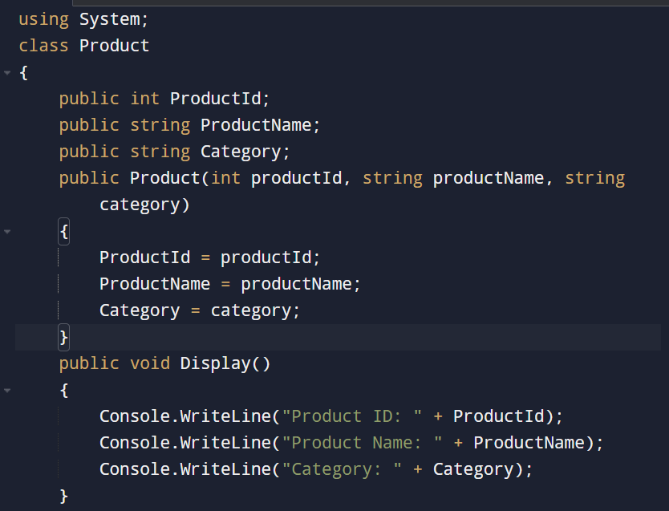

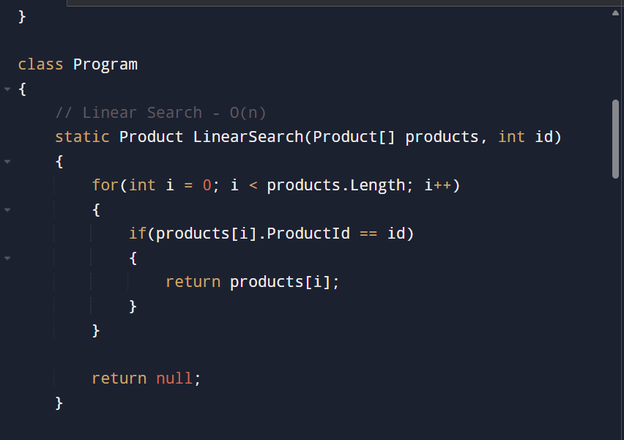
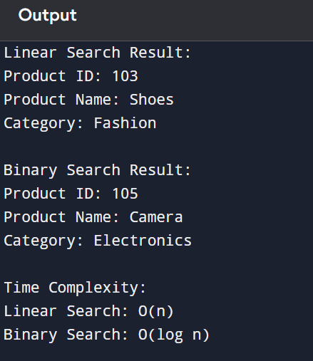

Exercise 7: Financial Forecasting

1. Understand Recursive Algorithms

Recursion
- Recursion is a technique where a method calls itself to solve a smaller part of a problem.
- It simplifies problems by breaking them into smaller repeated tasks.
- A recursive method contains:
  - Base Case: Condition to stop recursion.
  - Recursive Case: The method calls itself with a smaller input.

Advantages:
- Makes complex problems easier to understand.
- Reduces code complexity.

Disadvantages:
- Can consume more memory due to multiple function calls.
- May perform unnecessary calculations.

2. Setup
- Create a recursive method to calculate future financial values.
- The method uses:
  - Initial investment amount.
  - Growth rate.
  - Number of years.
- Formula:
Future Value = Current Value × (1 + Growth Rate)

3. Implementation
- The recursive algorithm calculates future value year by year.
- Each recursive call calculates the value for the next year.
- The recursion stops when the number of years becomes zero.

4. Analysis

Time Complexity:
- Each year requires one recursive call.
- Time Complexity: O(n)
- Space Complexity: O(n) due to recursive call stack.

Optimization:
- Use memoization to store previously calculated values.
- Avoids repeated calculations.
- Reduces execution time and memory usage.

Conclusion:
- Recursive algorithms provide a simple way to calculate future financial values.
- For large forecasting periods, optimization techniques like memoization or iterative approaches can improve performance.
